A PROJECT REPORT ON A PROPOSED STUDENT MANAGEMENT SYSTEM (SMS)

For

WOMEN’S INSTITUTE OF TECHNOLOGY & INNOVATION - UGANDA
Prepared by
NABATANZI GORRET AND KOBUMANZI ESETHER

In Partial Fulfillment of the Requirements for the Award of a Degree in a Bachelor of Science in Computer Science of Uganda Technology and Management University.
Supervisor
Ms Komunte Mary
School of Computing and Engineering, UTAMU

December 10, 2024

ABSTRACT
The Student Management System (SMS) for Women’s In Technology and Innovation - Uganda (WITI) is a digital solution designed to streamline the management of student records, attendance, grades, and notifications. The project aims to replace traditional paper-based and file-based methods with a centralized, automated system to improve accuracy, accessibility, and operational efficiency.
A key feature of the system is its QR code-based attendance tracking, which enables students to scan a unique code for each class session, ensuring real-time and accurate attendance recording. The system provides distinct interfaces for students, facilitators, and administrative staff, offering functionalities such as student registration, grade management, attendance reporting, and analytics. Facilitators can effortlessly manage classroom data, while students can access personalized academic records, and receive notifications.
The system leverages strong back-end services and a well-structured database to maintain data integrity and scalability. By enhancing operational processes and reducing manual errors, the SMS promotes a modernized and efficient approach to student management. This project illustrates the integration of technology to meet the evolving needs of educational institutions, setting a benchmark for innovation and effectiveness in academic administration.

DECLARATION
We, Nabatanzi Gorret & Kobumanzi Esether, hereby declare that this project report titled "Student Management System for Women’s Institute of Technology & Innovation (WITI)" is our original work and has been carried out to fulfill the course requirement of System Analysis and Design - IS 200 at UTAMU. This work has not been submitted to any other institution for any academic award or certification.
Students’ Signature
.................................................................................................
.................................................................................................
Date.........................................................................................

Approval
This work has been submitted for examination with the approval of
.........................................................................................
Ms Komunte Mary
School of Computing and Engineering

TABLE OF CONTENTS

ABSTRACT 1
DECLARATION 3
TABLE OF CONTENTS 4
CHAPTER 1: INTRODUCTION 1
1.1 Organization Background 1
1.2 Problem Statement 1
1.3 Objectives of the proposed system 1
.3.1 Main Objective 1
1.3.2 Specific Objectives of the proposed system 1
1.4 Significance of the System 2
1.5 Justification 2
1.6 System Scope 2
CHAPTER 2: FEASIBILITY STUDY 2
2.1 Introduction 2
2.2 Purpose for the Study 3
2.3 Objectives of the Study 3
2.4 Scope of the Study 3
2.4 Feasibility Analysis 4
2.4.1 Technical Feasibility 4
2.4.1.1 Current Infrastructure Assessment 4
2.4.1.2 Technology Requirements 4
2.4.2 Operational Feasibility 5
2.4.3 Economic Feasibility 6
2.4.3.1 Total Development Costs 6
2.4.3.2 Cost-Benefit Analysis 7
2.4.4 Conclusion 7
CHAPTER 3: FIELD STUDY AND REQUIREMENTS GATHERING 8
3.1 Objective of Requirement Gathering 8
3.2 Methodology for Requirement Gathering 8
3.2.1 Desired Functionalities in the SMS 9
3.2.2 Desired Approach for Attendance Management 10
3.2.3 Challenges with the Current File-Based Approach 10
3.2.4 Expected Roles and Tasks for Users 10
3.2.5 Student Application Flow 11
3.2.6 Information Management Requirements 11
3.2.7 Reporting and Data Insights 11
3.3 System Requirements 12
3.3.1 Functional Requirements 12
3.3.2 Non-Functional Requirements 13
3.3.3 Business Rules 14
3.3.3.1 Integrity Constraints on Data 14
3.4 Conclusion 16
CHAPTER 4: SYSTEM DESIGN AND ARCHITECTURE 16
4.1 Introduction 16
4.1.1 Entity-Relationship Diagram (ERD) 16
4.1.2 Data Flow Diagram (DFD) 18
4.1.3 Modular Diagram 19
4.1.4 System Architecture Diagram 21
4.1.5 Use Case Diagram 22
4.1.6 Input and Output Design 24
4.1.7 Database Design 26
4.1.7.1 Working Database for WITI’s SMS 26
CHAPTER 5: CONVERSION STRATEGY AND GANTT CHART 29
5.1 Conversion Strategy 29
5.1.1 Reasons for Choosing a Phased Conversion Strategy 29
5.1.2 Phased Roll-out Plan 30
5.1.3 Benefits of the Phased Approach 32
5.2 Gantt Chart 32
APPENDICES 33
Requirements Gathering Interview Questions 33

CHAPTER 1: INTRODUCTION

1.1 Organization Background
Women’s Institute of Technology and Innovation (WITI) is a Code Academy founded by Women In Technology Uganda (WITU) with a strong vision to close the technological gender gap in Uganda. WITI focuses on empowering young women with the necessary skills to excel in the technology sector. The institute offers a Diploma in Computer Science and Entrepreneurship, catering to female students who have completed Uganda’s Advanced Certificate of Education (UACE) with a science-focused curriculum at their A-level.

1.2 Problem Statement
The Women’s Institute of Technology and Innovation (WITI) currently relies on file-based approaches for managing student records and paper-based methods for attendance tracking. This leads to duplication of records, frequent errors in record-keeping and attendance tracking, delays in accessing vital information. The absence of a centralized system hinders efficient data management and timely decision-making, affecting both students and staff.

1.3 Objectives of the proposed system

.3.1 Main Objective
The main objective of this project is to design and implement a comprehensive Student Management System (SMS) WITI that digitizes student records management. This system aims to replace the file-based approaches and paper-based methods with a centralized digital solution improving accuracy, eliminating data redundancy, ease accessibility and operational efficiency.

1.3.2 Specific Objectives of the proposed system
1. To gather requirements for the proposed digital system.
2. Design the process flows for the proposed system.
3. Develop a digitized Student Management System.
4. Test, Deploy and Implement the proposed system.

1.4 Significance of the System
The proposed system enhances WITI’s operational efficiency by transitioning from the existing manual processes to a modern digital system. The implementation of the Student Management System is expected to improve data accuracy of student records, eliminate data redundancy and streamline administrative tasks.

1.5 Justification
The Student Management System addresses the inefficiencies that arise from managing student data in the existing file-based system. By digitizing the student management system, we shall have centralized information management which in turn makes general administration easier and more efficient.

1.6 System Scope
The proposed system will focus on creating a digitized and centralized students records management system to track most of the student activity within the school. The project will focus on operations that directly apply to the students. This will lay the groundwork for potential future enhancements, such as integrating learning management features.

CHAPTER 2: FEASIBILITY STUDY

2.1 Introduction
The feasibility study explored the practicability of developing and implementing a Student Management System (SMS) for Women’s Institute of Technology and Innovation (WITI).

2.2 Purpose for the Study
The purpose of this feasibility study was to evaluate the potential of implementing a Student Management System (SMS) at Women’s Institute of Technology and Innovation (WITI).

2.3 Objectives of the Study
- Identify Challenges: Assess the current challenges faced by the manual student management system, including inefficiencies and inaccuracies in data handling.
- Evaluate Feasibility: Determine the feasibility of transitioning to a Student Management System (SMS) that improves accuracy, efficiency, and user experience.
- Analyze Costs and Benefits: Evaluate the potential costs and benefits associated with implementing the SMS, including impacts on administrative processes and overall institutional performance.
- Automate Administrative Processes: Streamline student registration, attendance tracking, and grading to reduce administrative workload.
- Enhance Data Accuracy and Security: Securely store and manage student records to minimize errors and unauthorized access.
- Improve Reporting and Analytics: Provide tools for generating reports on student performance and attendance to support better decision-making.
- Increase Accessibility: Enable easy access to academic records and course information for students and staff.

2.4 Scope of the Study
This feasibility study encompasses the following areas:
- Technical Aspects: Evaluation of the technical requirements for implementing a Student Management System (SMS), including infrastructure, software, and hardware capabilities necessary for efficient operation.
- Economic Aspects: Analysis of the financial implications of transitioning to an SMS, including initial costs, potential savings, and return on investment.
- Operational Aspects: Examination of how the SMS will integrate into existing workflows, improve administrative processes, and enhance overall institutional efficiency.

2.4 Feasibility Analysis

2.4.1 Technical Feasibility

2.4.1.1 Current Infrastructure Assessment
WITI possesses a robust technological infrastructure, including:
- Hardware: Sufficient computers in student labs and laptops provided to staff, all equipped with necessary software (like, web browsing).
- Network: Reliable Wi-Fi access supported by a network server.
- Cloud Hosting: A cloud shared hosting server already in use for the institution’s website, with good security protocols, including secure protocols and SSL certificates.
- Operating Systems: Both the computers in the computer and the laptops provided to the staff member have up to date Operating Systems (Windows, Ubuntu, MacOs)
- Support for the Proposed SMS: The existing infrastructure is capable of supporting the proposed SMS, as all necessary components are in place. The cloud server can accommodate the SMS, ensuring secure and efficient operations.

2.4.1.2 Technology Requirements
1. Technology Stack
- Frontend:Frameworks: Laravel Blade for templating, alongside Laravel Livewire for dynamic components.
- InfyOm: To streamline the development process with CRUD (Create, Read, Update, Delete) operations and scaffolding.
- Backend: PHP (Laravel framework)
- Database: MySQL
2. Hosting: The SMS will be hosted in the cloud, providing cost-effectiveness and scalability.
3. Security: Implementing security features such as encryption for sensitive data, multi-factor user authentication, and regular backups to ensure data integrity and security.
4. Operating System: The system will run on a server with a compatible OS, such as Ubuntu or CentOS, which are suitable for web applications and provide a stable environment for PHP and MySQL. During system use, the system will be multi-platform independent.
5. Additional Requirements: To optimize system performance and ensure seamless integration, WITI may need to consider:
- Upgraded Cloud Hosting Package: Enhancing to a better cloud shared hosting plan to increase server capacity.
- Improved Internet Connectivity: Upgrading internet services to support increased traffic and ensure reliable access.
Conclusion: The proposed Student Management System (SMS) is technically feasible, supported by WITI’s existing infrastructure, including sufficient hardware, reliable Wi-Fi, and a capable cloud hosting server. Recommended upgrades to the cloud package and internet connectivity will enhance performance. Overall, the institution is prepared for a successful SMS implementation.

2.4.2 Operational Feasibility
- Staff and Student Readiness: WITI’s staff and students are prepared to adapt to the new Student Management System (SMS). Staff members are proficient in similar systems, while many have software development knowledge.
- Integration into Current Workflows: The SMS will streamline tasks like registration, attendance tracking, and grading, reducing manual efforts and enhancing workflow efficiency.
- Training Requirements
- Staff: No training needed as they are already skilled in terms of the use of such systems
- Students: Basic training sessions may be offered by staff to ensure familiarity with the SMS features.
Conclusion: Overall, the operational feasibility of implementing the SMS at WITI is strong, given the readiness of both staff and students, the positive impact on existing workflows, and the minimal training requirements. This readiness supports the successful adoption and long-term use of the proposed system

2.4.3 Economic Feasibility

2.4.3.1 Total Development Costs
- Development Costs
- Student Developers
5 Best students working for 3 months.
Total = 5 students × UGX 300,000 × 3 months = UGX 4,500,000.
- Professional Developer
1 Proficient developer working for 3 months.
Total = UGX 2,000,000 × 3 months = UGX 6,000,000.
- Infrastructure Costs
Cloud Hosting: UGX 200,000 per year.
- Testing Costs
Since WITI staff can effectively test the functional features and provide feedback, this will reduce additional costs associated with third-party testing. Therefore, UGX 0 for testing.
- Maintenance Costs
Estimated at UGX 600,000 annually for the developer’s maintenance support after deployment.
Total Estimated Project Costs = UGX 11,300,000

2.4.3.2 Cost-Benefit Analysis
Expected Benefits
By leveraging the expertise of WITI's best students and a proficient developer, the institution minimizes development costs while providing valuable learning opportunities for students.
The collaboration will enhance students' skills and practical experience while ensuring that the system aligns with WITI’s needs. The anticipated benefits of increased operational efficiency, improved data management, and support for WITI’s mission to bridge the technological gender gap will outweigh the development and maintenance costs.

2.4.4 Conclusion
The feasibility study for the proposed Student Management System (SMS) at the Women’s Institute of Technology and Innovation (WITI) supports its implementation across all dimensions.
Technical Feasibility: WITI has the necessary hardware, software, and network infrastructure, including cloud hosting, to support the SMS, which will utilize PHP (Laravel) and MySQL.
Operational Feasibility: Staff and students are ready to adapt to the new system, with proficient staff available to train students. Student developers will collaborate on the project, ensuring smooth integration into existing workflows.
Economic Feasibility: The estimated cost for development and maintenance is UGX 11,300,000. Utilizing existing resources and student involvement minimizes costs while enhancing efficiency and data accuracy.
In summary, the SMS project is feasible and aligns with WITI’s mission to provide quality education and bridge the technological gender gap in Uganda.

CHAPTER 3: FIELD STUDY AND REQUIREMENTS GATHERING

3.1 Objective of Requirement Gathering
The objective of requirement gathering for the Student Management System (SMS) is to fully understand user needs, define essential functionalities, and establish standards for security, usability, and performance. This process also identifies any technical or organizational constraints and sets business rules to ensure data integrity and proper access, creating a system that supports the institution’s academic and administrative needs effectively.

3.2 Methodology for Requirement Gathering
The primary requirements gathering instrument was interviews with guided questions. This format enabled us to capture in-depth responses, allowing participants to elaborate on their experiences and expectations for the SMS. The interview questions covered the following areas;
- Desired functionalities in the SMS.
- Challenges with the current file-based system.
- Expected roles and tasks for different user types.
- Types of student information the SMS should manage.
- Specific reporting and data insights required.
Participants
We collected data from a total of 15 participants, including students, lecturers, and administrative staff, who are primary users of the system. Their responses provided valuable input for defining system requirements.
Data Collection Process
Interviews were conducted in person to encourage detailed responses and allow interviewers to
clarify questions as needed. Responses were documented to ensure accurate analysis and insights
for each key area.
Data Analysis
This section summarizes the feedback gathered during the interviews, highlighting the essential
requirements and functionalities that the SMS should incorporate.

3.2.1 Desired Functionalities in the SMS
Participants identified several crucial functionalities, including:
- Student Application : Simplifying and digitizing the application process for new students.
- Academic Resources: Access to lecture notes, assignments, exam schedules, and resources such as textbooks.
- Centralized Academic Calendar: Displaying important dates, including assignment deadlines and exam schedules.
- Payment Processing: Tracking tuition fees, generating receipts, and managing outstanding balances.
- Attendance Management: A QR code scanning feature for recording attendance accurately and efficiently.
- Grade Assessment and Feedback: Storing assessment records with lecturers' comments and feedback.
- Reporting and Analytics: Generating reports for attendance, grades, and performance tracking.
- Notifications and Alerts:The system should send notifications to students on each system event. The system should notify facilitators on all system activity events.
- Data Export: The system should allow both administrators and facilitators to export attendance and grade data in various formats (e.g., PDF, Excel).

3.2.2 Desired Approach for Attendance Management
Participants emphasized the need for an efficient QR code-based attendance management system.
The suggested approach involves:
- QR Code Generation: Each class or event would have a unique QR code generated by the system.
- Attendance Logging: Students scan the code with their devices when attending classes, which logs their attendance in real time.
- Tracking and Reporting: The system maintains a record of attendance logs, enabling lecturers and administrative staff to view daily or cumulative attendance summaries and address any inconsistencies. This approach is expected to save time, reduce inaccuracies, and simplify attendance tracking, especially compared to manual entry methods.

3.2.3 Challenges with the Current File-Based Approach
Participants cited several issues with the existing file-based system:
- Slow data retrieval and delays in accessing student records.
- Inefficiencies in manually updating student information.
- Challenges in tracking attendance accurately.
- Limited capabilities for generating reports on student progress and attendance.

3.2.4 Expected Roles and Tasks for Users
- Students: Registration, course enrollment, attendance tracking, and accessing grades and feedback.
- Lecturers: Uploading and managing assignments, tests, exams, and tracking student performance.
- Administrative Staff: Overseeing student records, processing enrollments, managing payment records, and generating reports.

3.2.5 Student Application Flow
Participants highlighted the need for a streamlined student application process, which could involve:
- Application Submission: Prospective students submit their applications via the company website, uploading necessary documents and filling in required information.
- Application Review: Administrative staff reviews the applications, checks for eligibility, and flags any incomplete submissions.
- Approval and Enrollment: Approved applications move forward in the process, and students are officially enrolled into the system. An automated notification confirms their enrollment status and provides them with access credentials.
- Tracking and Follow-Up: The system allows prospective students and administrative staff to track application status and follow up as necessary.
This flow aims to improve the application experience, reduce paperwork, and provide a clear tracking mechanism for both applicants and staff.

3.2.6 Information Management Requirements
Participants emphasized that the SMS should be able to:
- Maintain comprehensive records on each student, including personal information, academic progress, and attendance.
- Provide a user-friendly interface for storing and retrieving student-related data.

3.2.7 Reporting and Data Insights
Participants expressed the need for regular, accessible reports, including:
- Attendance summaries to monitor student engagement.
- Grade distribution and academic performance reports.
- Enrollment and payment tracking for administrative analysis.

3.3 System Requirements

3.3.1 Functional Requirements
Based on interview responses, the following functional requirements have been identified for the SMS:
- User Management
- Define roles (Student, Lecturer, Admin) with specific access permissions.
- Manage user profiles, including secure login credentials and role-based access.
- Student Information Management
- Store and manage essential student details, such as ID, contact information, and academic records.
- Enable easy access to attendance records, grades, and feedback from lecturers.
- Enrollment and Registration
- Allow students to register for courses digitally.
- Enable administrative oversight of course enrollment status.
- Course Management
- Manage course information, including objectives, outcomes, and content.
- Allow lecturers to update course-related materials and assessments.
- Attendance Tracking
- Provide QR code scanning for quick attendance logging.
- Track attendance and generate reports on student engagement.
- Student Application
- Streamline the application process with an online submission, review, and tracking mechanism.
- Allow administrative staff to review applications, manage enrollment statuses, and notify applicants.
- Academic Calendar
- Maintain a centralized calendar with key dates, such as assignment deadlines and exam schedules.
- Allow updates by administrative staff for real-time access.
- Payment Processing
- Track tuition and fee payments, with receipt generation and reporting.
- Enable administrators to monitor payment records for financial management.
- Grading and Assessment
- Allow lecturers to input grades and provide feedback.
- Enable students to view grades and comments in real time.
- Reports and Analytics
- Generate customized reports on attendance, grades, and course progress.
- Provide analytics to aid in academic and administrative decision-making.

3.3.2 Non-Functional Requirements
These requirements specify the expected performance, security, and usability standards of the SMS.
1. Usability: The system interface should be user-friendly, with simple navigation for different roles (students, facilitators, administrators).The system should be accessible across devices, including desktops, tablets, and smartphones.QR code scanning shall be efficient, requiring minimal interaction for attendance capture.
2. Reliability: The system should function consistently, with minimal downtime and robust data backup mechanisms.
3. Performance: The system must process data quickly to prevent delays in retrieving or updating information.
4. Security: Role-based and permission access control alongside user authentication are required to protect sensitive data. The system should use secure logins with password protection for all user roles. All data transmissions, including QR code data, should be encrypted. The system should enforce confidentiality.
5. Scalability: The system should be capable of handling increasing numbers of users and data entries without impacting performance.
6. Data Integrity: Ensure data is accurate and modifications are authorized.
7. Compliance: Adhere to relevant data protection regulations, such as GDPR, to safeguard user data.

3.3.3 Business Rules
The following business rules define operational principles and integrity constraints for the WITI Student Management System (SMS). These rules outline data relationships and access restrictions to ensure system integrity and enforce specific requirements for managing students, staff, and academic programs.

3.3.3.1 Integrity Constraints on Data
- Department and Institute Relationships
- Every department added must belong to the institute.
- Role and Permission Management
- The system can have one or more roles.
- Each permission must belong to a role.
- A role can have multiple users assigned to it.
- User Data Integrity
- Each user must have a unique email and phone number.
- A user must have an assigned role.
- Program Structure
- A program is limited to two semesters per year.
- Each program can have one or more cohorts.
- Programs must have unique names to avoid confusion.
- Course and Semester Organization
- A course must be assigned to a specific semester.
- Each semester can include one or more courses.
- Each semester must have a unique name.
- Each course must have a unique name.
- Cohort and Student Associations
- Cohorts must have unique names.
- Each cohort can contain multiple students.
- Every student must have a unique registration number.
- A student can only belong to one cohort
- Facilitator and Course Assignments
- Each facilitator can only teach one course.
- Application Process
- A new student can only apply once for a specific course for every intake.
- Applications are tied exclusively to individual students.
- An application form can include one or more referral sources.
- There can be one or more referral sources.
- Student Enrollment and Cohort Requirements
- Every student must be assigned to a particular cohort.
- Students must enroll in each new semester.
- A student can enroll in multiple courses (course units) within a given semester.
- Grades Assessment
- Coursework and tests contribute 40% of the final grade, while the final exam contributes 60%.
- Students scoring below 50% must retake the course unit with a fee of UGX 30,000
- Each grade entry must link to a valid student and course.
- Grades below 50% automatically trigger a retake requirement.
- Each lecturer can only add marks for the course he or she teaches.
- Students can comment on their marks scored
- Each student can access only their student details and scored marks.
- Attendance with QR Code requirements
- Students must scan a QR code to mark attendance, verifying presence at the scheduled time and location.
- Attendance contributes to the final grade, with thresholds for minimum required attendance (10%) for course completion.
- Each QR code is unique to the session and expires after a set time to prevent misuse.
- QR codes are linked to specific courses and students, ensuring valid attendance records.
- Only students physically present can mark attendance to avoid proxy check-ins.
- Financial Obligations
- A student must pay at least half of their tuition to gain access to the system.
- Some students are given scholarships.

3.4 Conclusion
The field study provided key insights into the requirements for the Student Management System (SMS). Participants highlighted essential features such as student data management, assignment tracking, and attendance solutions, while noting challenges in the current file-based system, like inefficiency and limited accessibility. Clear user roles and tasks for students, lecturers, and staff were identified, along with a need for regular reporting and data insights. These findings form a solid foundation for developing a system that will address existing limitations and enhance institutional efficiency.

CHAPTER 4: SYSTEM DESIGN AND ARCHITECTURE

4.1 Introduction
This chapter presents the system design and architecture of the Student Management System (SMS) for WITI’s Code Academy. It includes diagrams that illustrate various aspects of the system, such as data flow, system components, database structure, and user interactions. These visual representations are complemented by explanations to provide a comprehensive understanding of the proposed solution.

4.1.1 Entity-Relationship Diagram (ERD)
The ERD shows the logical structure of the database, illustrating the relationships between various entities. Key entities include Student, Courses, Facilitator, Administrator, Attendance, and Grading, each with their respective attributes and relationships. The ERD ensures data normalization and consistency, forming the foundation for the system's database design.
Purpose:
- To define the data structure of the SMS.
- To ensure efficient data management and reduce redundancy
ENTITY RELATIONSHIP DIAGRAM (ERD) FOR WITI’S STUDENT MANAGEMENT SYSTEM

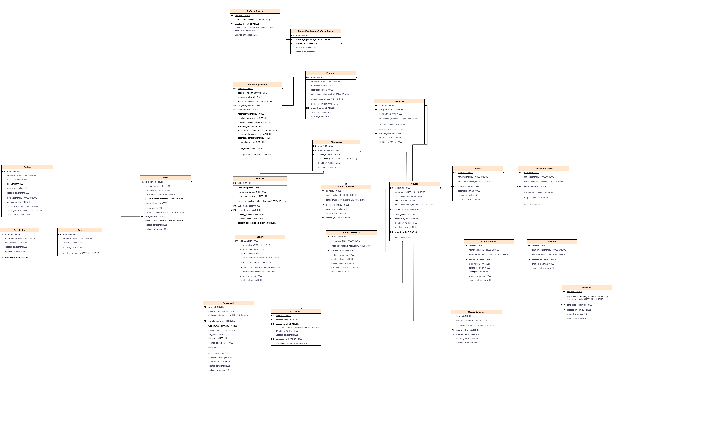
Entity Relationship Diagram for witi sms 1

4.1.2 Data Flow Diagram (DFD)
The DFD provides an overview of the system's functional flow.
- Level 0: Represents the overall SMS process, showing how data flows between users and the system.
- Level 1: Breaks down the core processes such as Attendance Management, Student Registration, and Grade Management.
- Level 2: Details the sub-processes, such as QR Code Scanning for attendance and Report Generation.
Purpose:
- To identify system processes and data flow pathways.
- To establish clear communication between modules.
DATA FLOW DIAGRAMS FOR WITI’S STUDENT MANAGEMENT SYSTEM
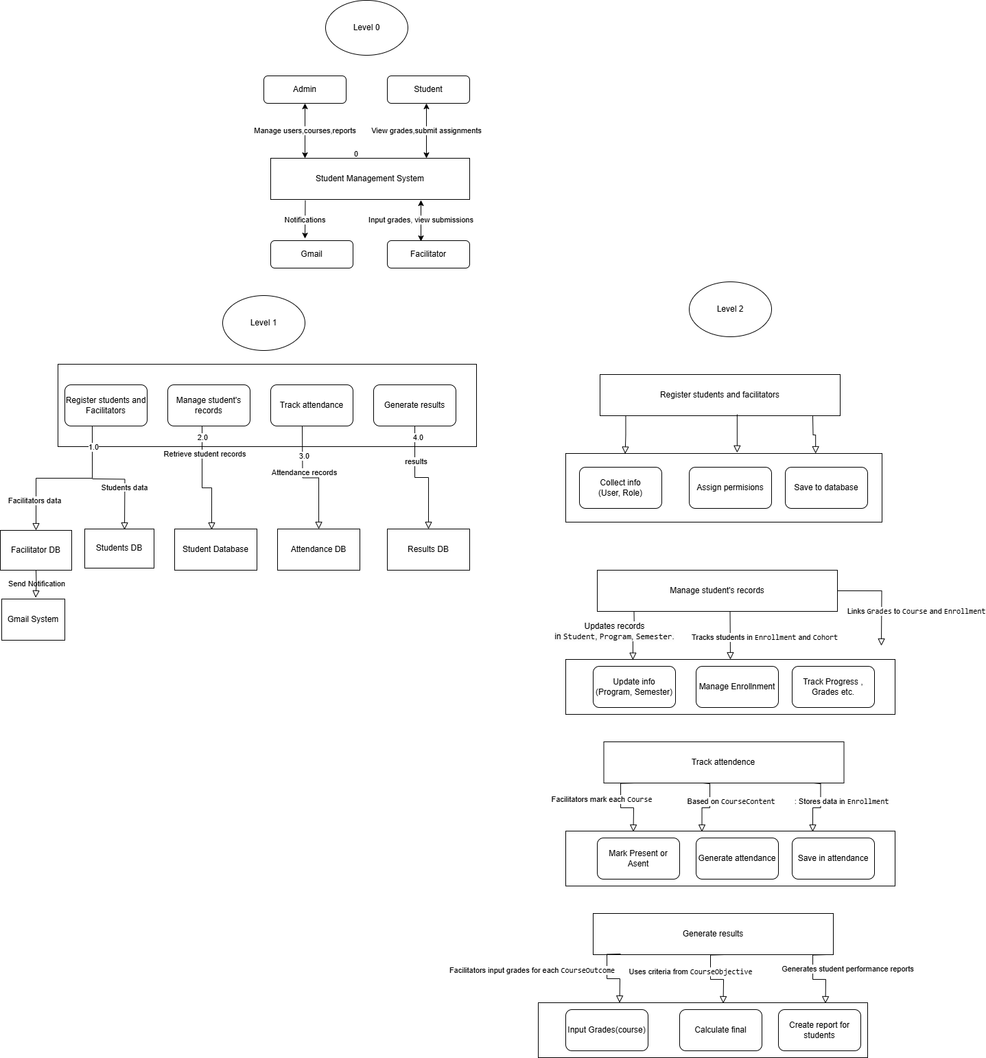
Data Flow Diagram for WITI SMS 1

4.1.3 Modular Diagram
The modular diagram showcases the system’s components and their interactions. Modules include:
- Student Module
- Administrator module
- Attendance Management Module (with QR Code Integration)
- Program Module
- Assessment module
- Facilitator module
- Payment module
- User interface module
- Data Module
Purpose:
- To ensure modularity and scalability in the system.
- To enable independent development and testing of system components.
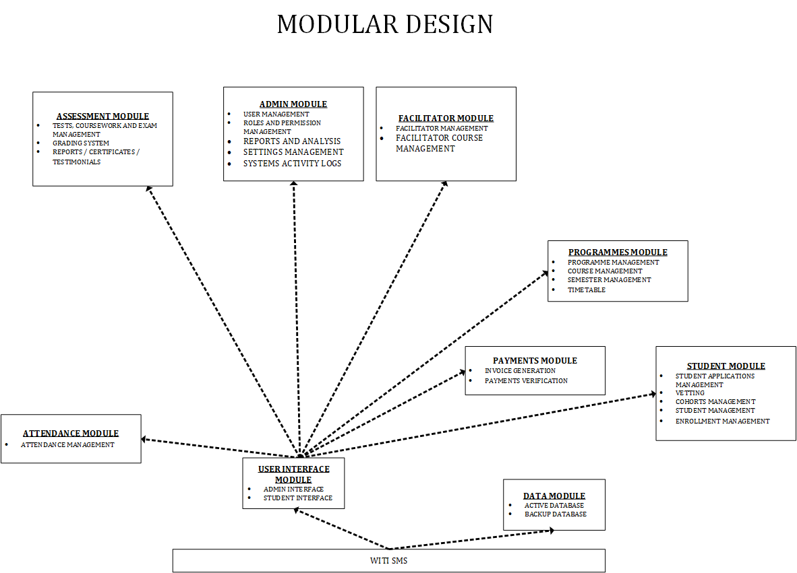
Modular Diagram for WITI SMS 1

4.1.4 System Architecture Diagram
The architecture diagram illustrates the system's high-level structure, including:
- User Interface Layer: Mobile and web applications for students, faculty, and admin.
- Application Layer: Backend services such as QR code generation, attendance management, and analytics.
- Data Layer: Centralized databases for students, attendance, and grades.
- Hardware/presentation Layer: Mobile devices, desktops and servers.
- Network layer: network infrastructure.
Purpose:
- To provide an overall view of the system’s architecture and interaction points.
- To highlight the integration of QR code technology in attendance management.
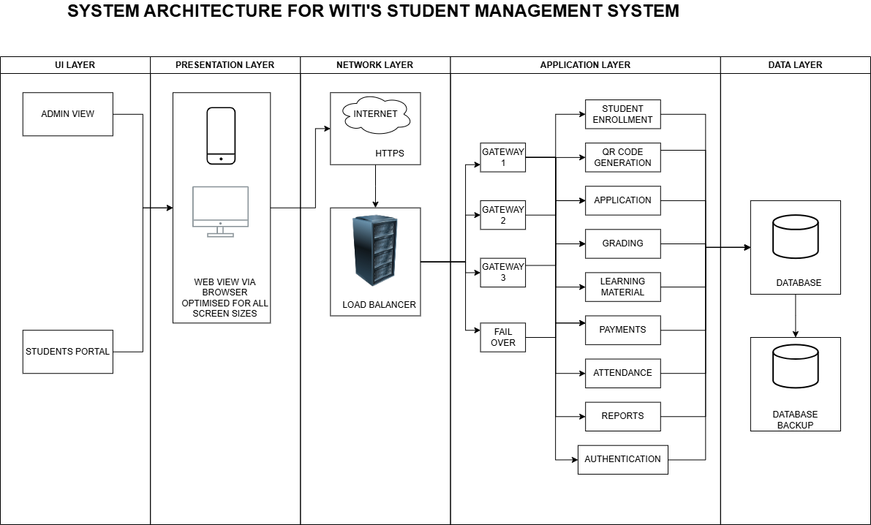
System Architecture Design 1

4.1.5 Use Case Diagram
The use case diagram identifies the system's key actors (Students, Faculty, Admin Staff) and their interactions with the system's functionalities. Major use cases include:
- Student Registration
- QR Code Attendance Capture
- Grade Input and Management
- Report Generation
Purpose:
- To visualize user interactions with the system.
- To define user roles and access permissions.
USE CASE DIAGRAM FOR WITI’S STUDENT MANAGEMENT SYSTEM
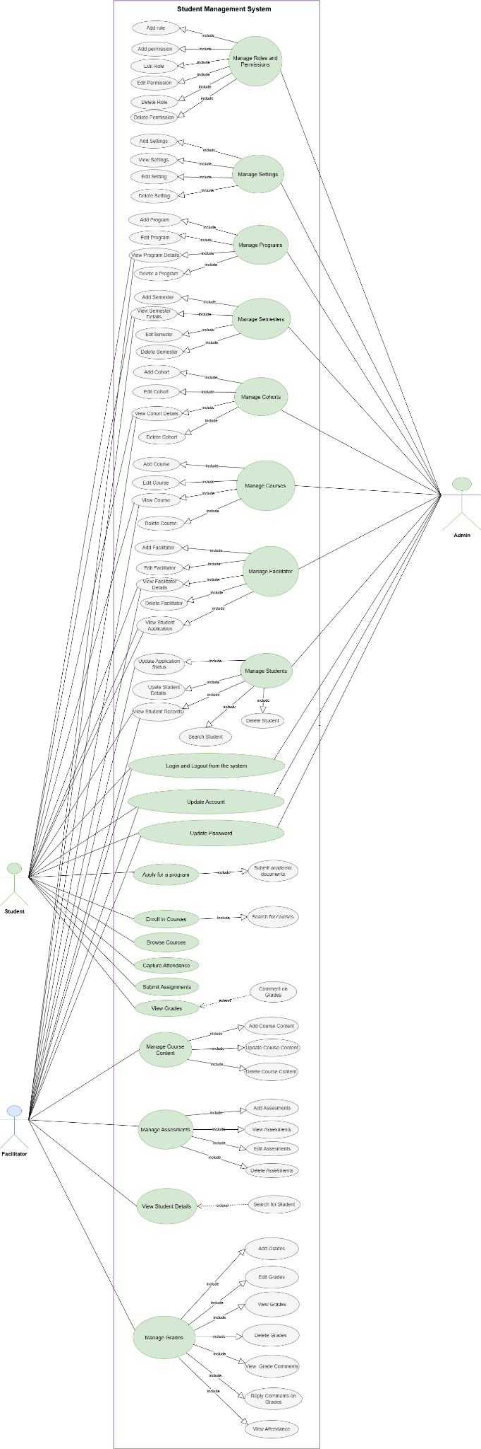
Use Case Diagram for WITI SMS 1

4.1.6 Input and Output Design
This section outlines the design of user interfaces for input and output.
Purpose:
- To ensure user-friendly and intuitive interfaces for data entry and report generation.
- To improve accessibility and usability for all stakeholders.
4.1.6.1 Input Design:
- Add program Form: shows the fields that should be filled and action buttons.
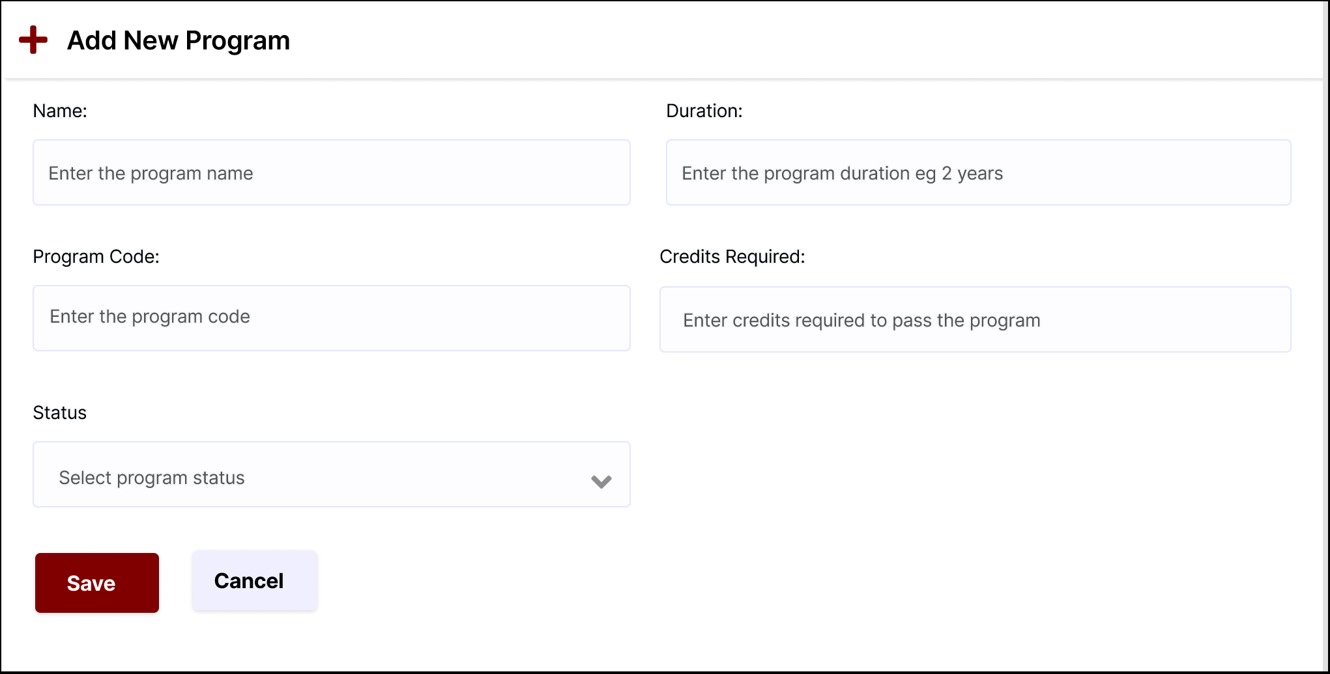
Input design for adding a new program 1
- Add user: admin adding new users for the system and their status.
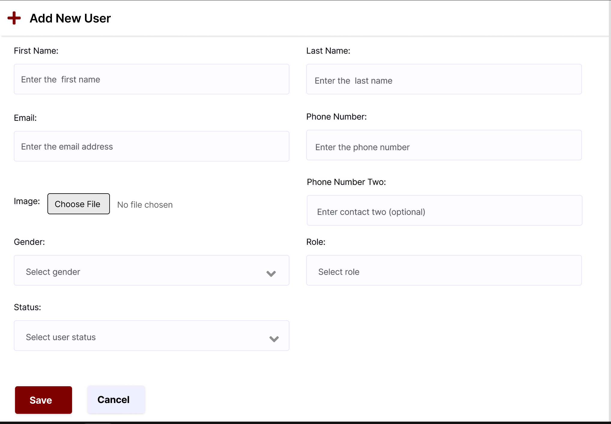
Input design for a adding a new user 1
4.1.6.2 Output Design:
- All programs: a display of all programs offered by the institution.
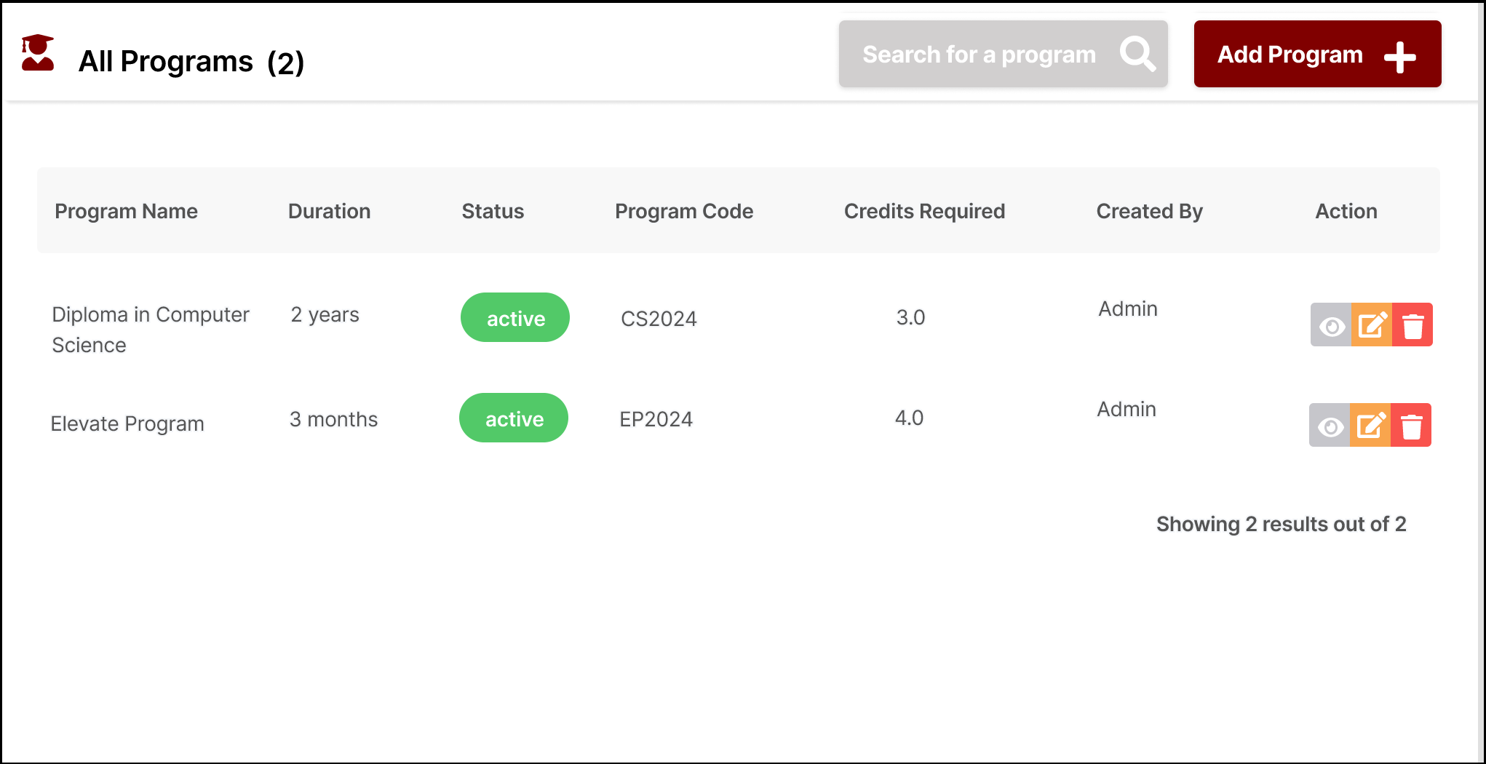
Output Design for added programs 1
- All users: all system users and their status.
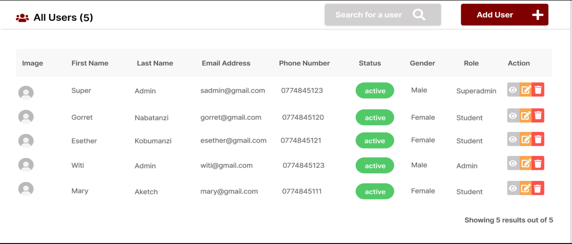
Output design for added users 1

4.1.7 Database Design
The database design section includes:
- Normalized Tables: Detailed structure of tables for Roles, Permissions, Users, Students, Programs, Semesters, Cohorts, Courses, Attendance, Grades,etc .
- Primary and Foreign Keys: Key relationships between tables to ensure data integrity.
Purpose:
- The purpose of the database for the system is to store, organize, manage, and retrieve data efficiently and securely.

4.1.7.1 Working Database for WITI’s SMS
Below is the design of the database and some main tables
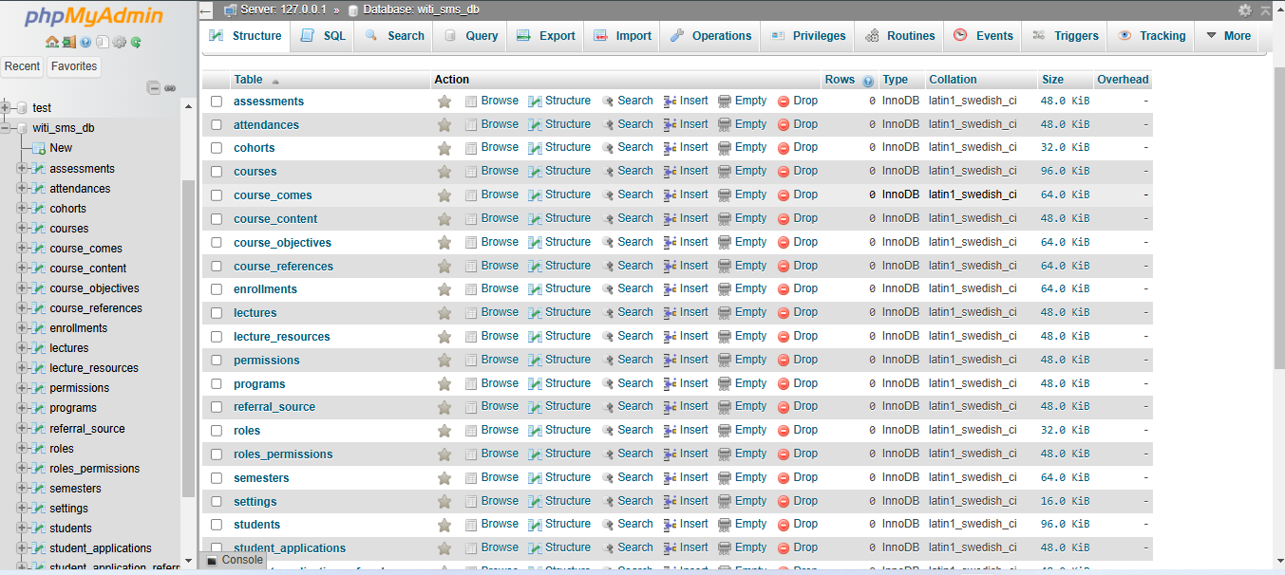
Database Tables View One 1
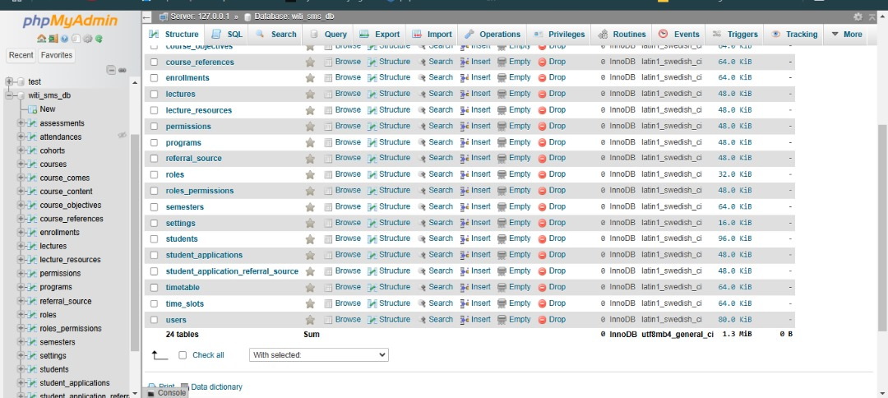
Database Tables View One 2

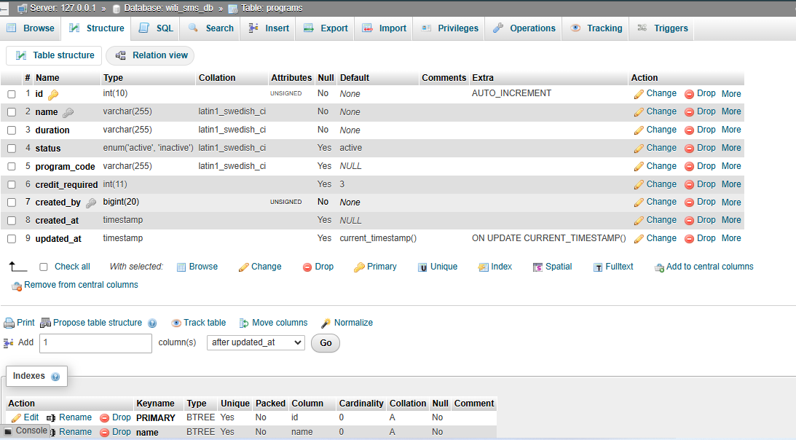
Program tables structure 1
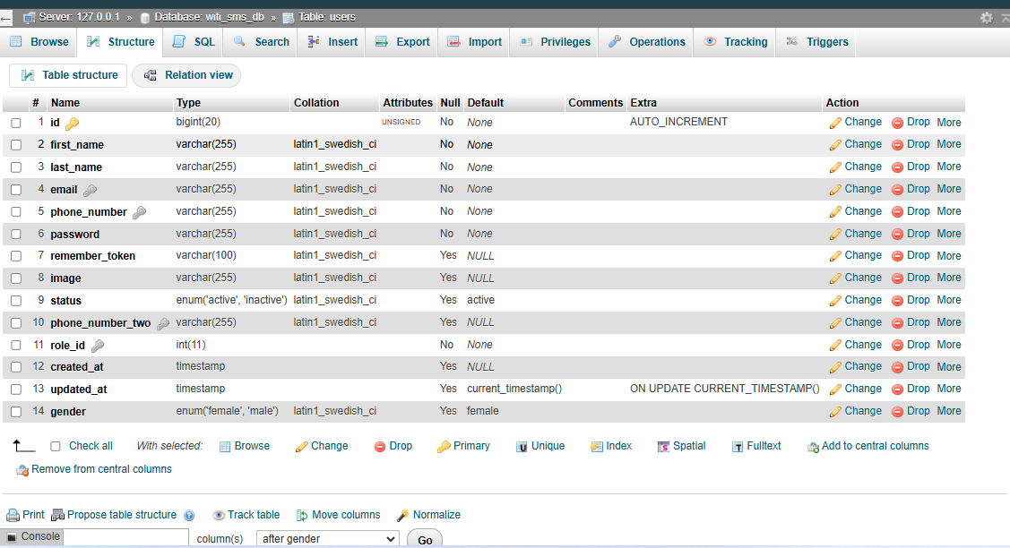
Table structure for users 1

CHAPTER 5: CONVERSION STRATEGY AND GANTT CHART

5.1 Conversion Strategy
A Conversion Strategy refers to the approach used to transition from an existing system to a new system. The conversion strategy recommended for WITI’s Student Management System is a Phased (Gradual) Conversion, as it allows the institution to transition smoothly and gradually to the new Student Management System (SMS), by implementing and testing modules of the system for use while continuing to use the existing file-based system (Google Sheets/Excel).
The Phased Conversion involves a gradual introduction of the new system, while at the same time replacing elements of the current system until the current system is completely replaced by the new system. It allows users to adapt incrementally while minimizing risks associated with a direct conversion. This conversion method is the least risky with respect to implementing the WITI’s student management system.

5.1.1 Reasons for Choosing a Phased Conversion Strategy
1. Minimal Risks: By implementing the system module by module, any potential issues can be identified and resolved before the full system is deployed.
2. User Training and Adaptation: Staff and students can be trained on specific components of the system during each phase, reducing the learning curve and ensuring higher user adoption.
3. Minimal Disruption: Core operations of the institution can continue running without interruption, as the existing system will remain operational for areas not yet transitioned.
4. Data Integration: During the transition, data from Google Sheets/Excel can be imported incrementally into the new system, ensuring data consistency.
5. Scalability and Feedback: Each phase allows the institution to gather feedback, improve functionalities, and make adjustments on the remaining modules before full deployment

5.1.2 Phased Roll-out Plan
A roll-out refers to the process of deploying and implementing a new system or software within an organization. Our plan involves a phased and structured deployment of modules ensuring minimal disruption, early identification of issues, and smooth integration of the new system into the institution's operations.
The following are the Roll-out Phases that will be used for the conversion strategy identified;
Phase 1: System Administration
This will be the pilot phase since it establishes system administration and access control, a critical foundation for subsequent modules. It will enable user management and role-based access for users. It will consist of the following roll-out tasks;
- Deployment of the Admin Module (users, roles and settings management).
- Creating roles, users like admins and facilitators and assigning them roles.
- Testing user account creation, password policies, and role-based restrictions.
- Providing training on system administration.
Phase 2: Programs Management
This phase will then come next since it defines the academic structure (programs, semesters, and courses), which is essential for enrolling students and managing academic data. It will consist of the following roll-out tasks;
- Deployment of the Programs Module (programs, semesters, courses).
- Migrating existing program and course data from the existing Google Sheets/Excel.
- Setting up semesters and courses.
- Testing program creation, updates, edits and course linking with semesters.
Phase 3: Facilitator Management
This phase will be followed up so as to assign facilitators to courses they teach ensuring that course management is ready before student enrollment. It it will be made of the following roll-out tasks;
- Deployment of the facilitator module
- Importing facilitator details into the system.
- Assigning facilitators to specific courses.
- Testing workflows for updating and managing facilitator course assignments.
Phase 4: Student Management
This roll-out phase will then be followed to enable management of applications, student data and enrollments, integrating with existing facilitator and course data. It will involve the following roll-out tasks;
- Deployment of the student module (applications, students registration, enrollments).
- Transferring existing student data into the new system.
- Testing the data added.

Phase 5: Attendance Management
This phase will involve rolling out the attendance module using the following tasks;
- Rolling out the QR Code-Based Attendance features.
- Training faculty and students to use the QR scanning functionality.
- Testing attendance records for accuracy and consistency.
Phase 6: Grading and Reporting
This phase will involve rolling out of the assessment features for grading and reporting analysis with the following tasks;
- Deploying the Grading Management and Analytics Modules.
- Training faculty to input and manage grades using the system.
- Testing reporting features by faculty and administrative staff.
Phase 7: Full System Deployment
This will be the last phase to ensure that all the system features are fully integrated and work seamlessly together. It will include the following roll-out tasks;
- Integration of all modules and extending the system to all users.
- Conducting system-wide testing and finalizing documentation.
- Providing continuous support and troubleshooting as users fully transition to the new system.

5.1.3 Benefits of the Phased Approach
1. Incremental implementation allows for iterative improvements.
2. Users become familiar with the system gradually, reducing resistance to change.
3. The institution can manage resources effectively without overwhelming staff or budgets.

In conclusion, we recommend a Phased (Gradual) Conversion strategy for rolling out the Student Management System for Women In Technology Uganda since it minimizes risks, allows for iterative improvements and ensures smooth transitioning, by implementing and testing modules of the system in phases for use while continuing to use the existing file-based system until the whole system is fully ready, thus ensuring that WITI successfully adopts to the new system effectively.

5.2 Gantt Chart
A Gantt chart is a visual representation of a project schedule, showing the start and finish date of several elements of a project. It is used to plan and track the tasks and phases of a project as seen below.
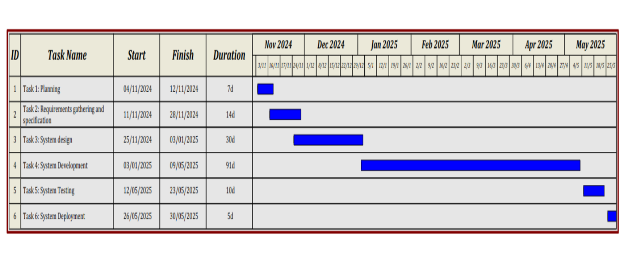
A Gantt Chart for the project timeline 1

APPENDICES

Requirements Gathering Interview Questions
1. What key features or functionalities would you like to see included in this student management
system?
2. What specific challenges are you currently facing with the file based approach that this system should solve?
3. Who do you expect will use the system, and what tasks should each user type be able to
perform?
4. What types of student information should the system be able to store, track, and report on?
5. Are there any specific reports or data insights you would need from the system on a regular
basis?

